Metering Installation Error Report

(Data source: explore_1.xlsx. Error calculated: Fri Mar 13 14:01:00 2020.)
The error calculated for the given load profile is +0.76 %.
The expanded uncertainty at an estimated 95% level of confidence is 0.21 %.
The uncertainty interval extends from +0.54 % to +0.97 %.

Installation error over the phase and current ranges that match the load profile.
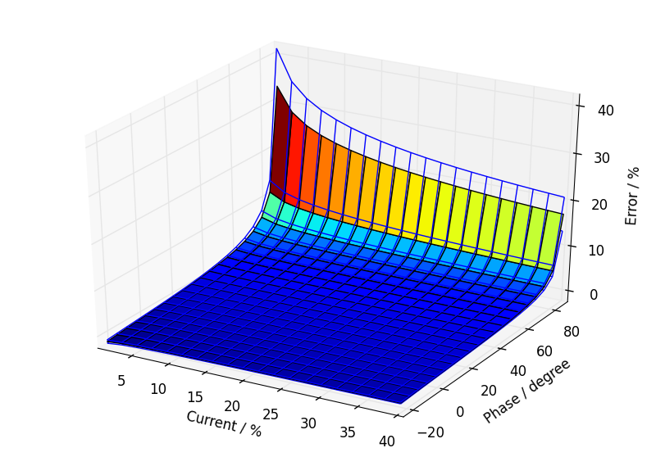

Annual load profile used for this error calculation.
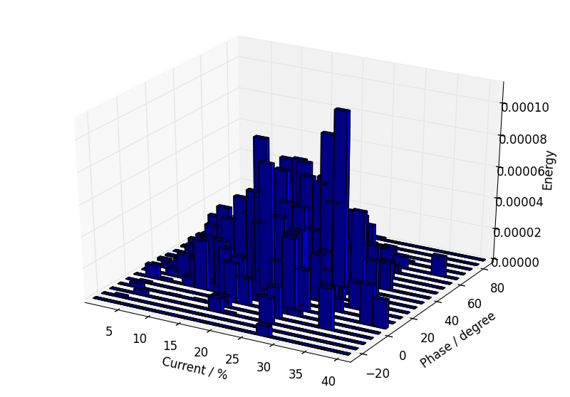

Component calibration data with calculated fits over the calibration ranges.

Current Transformer.
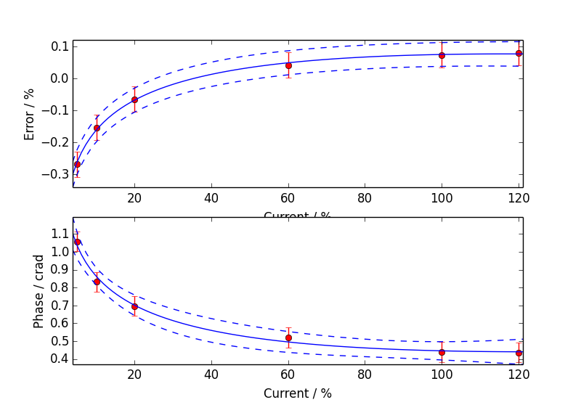

Voltage Transformer.
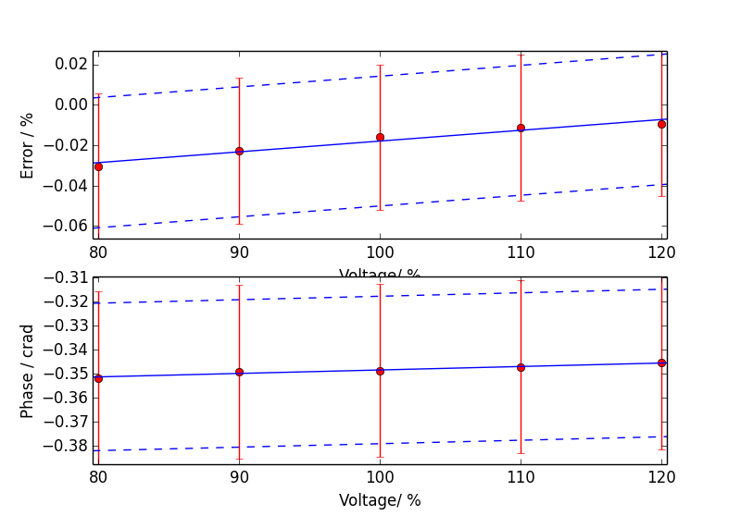

Meter.
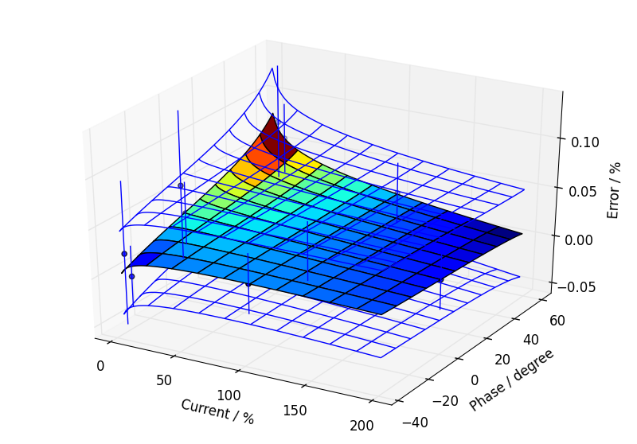

Additional Information

Uncertainty Contribution Summary
Uncertainty contribution by component as a percentage of total variance, Meter: 15 %, CT: 45 %, VT: 40 %.

Text Output From Calculation Process
Meter data
Fit has lower uncertainty than expected from calibration data, so type B component added.
CT ratio data
Fit has lower uncertainty than expected from calibration data, so type B component added.
CT phase data
Good fit.
VT ratio data
Fit has lower uncertainty than expected from calibration data, so type B component added.
VT phase data
Fit has lower uncertainty than expected from calibration data, so type B component added.

Load error, low or negative current
Load phase limited to 89.9 degrees maximum
Max current = 41.02 %, Min current = 0.10 %, Max phase = 89.90 degrees, Min phase = -26.95 degrees

Budget for overall error by coefficients

0.76, u=0.11, df=100.7
a2 CT_e: 0.0560681
a0 VT_e: 0.0515479
a1 VT_e: 0.05104
CT calibration burden: 0.0480323
Site CT burden: 0.0480323
a2 CT_p: 0.0425322
a0 CT_e: 0.0418284
a0 VT_p: 0.0395204
a1 VT_p: 0.0391311
Meter temperature coefficient: 0.0357071
a0 CT_p: 0.0320688
Meter harmonic dependence: 0.0282843
Site harmonics: 0.0282843
VT calibration burden: 0.0249255
Site VT burden: 0.0249255
Site voltage: 0.0224636
Meter voltage dependence: 0.0212132
b0 meter: 0.0202546
b0 CT_e: 0.0183737
b0 VT_e: 0.0163636
Site frequency: 0.0132676
Meter frequency dependence: 0.0132583
b0 VT_p: 0.0120235
a2 meter: 0.0116265
a1 CT_e: 0.0101311
Site temperature: 0.00991642
a3 meter: 0.00952438
a0 meter: 0.00824024
a1 CT_p: 0.00754207
a1 meter: 0.00165056
CT temperature coefficient of phase: 0.000767252
VT temperature coefficient of phase: 0.000364712
CT calibration temperature: 0.000187326
CT temperature coefficient of error: 0.000111611
VT calibration temperature: 9.72096E-05
VT temperature coefficient of error: 2.4479E-05

